School Of Mechanical & Manufacturing Engineering, NUST

Department of Mechanical Engineering

CS-114 - Fundamental of

Programming

Lab Report # 03

# Course Instructor: Khwaja Fahad Iqbal

**Lab Instructor:** Muhammad Affan

Student Name: Muhammad Ali Shahzadah

Section: B

Qalam: 466353

Department of Mechanical Engineering

**Objective:**

This lab is about the selection structure and understanding the types of selection structures.

Task 1:

Write a C++ program to print the total number of populations in Punjab, Sindh, KPK, and Balochistan using a switch case.

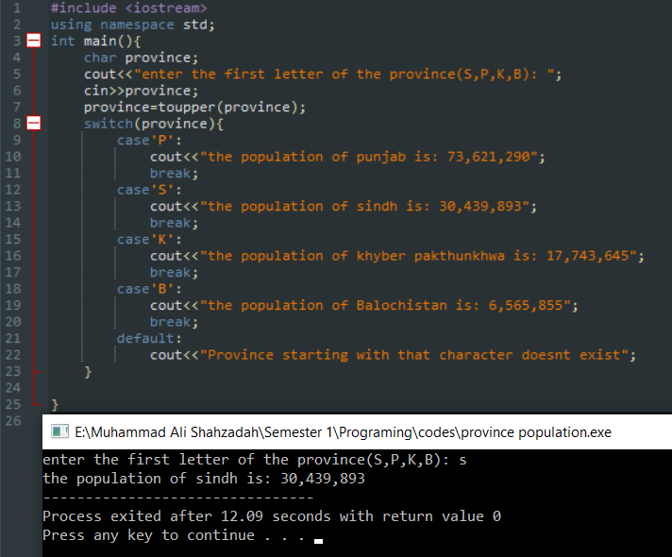

Task 2:

Write a C++ program to check whether an alphabet is a vowel or consonant using a switch case.

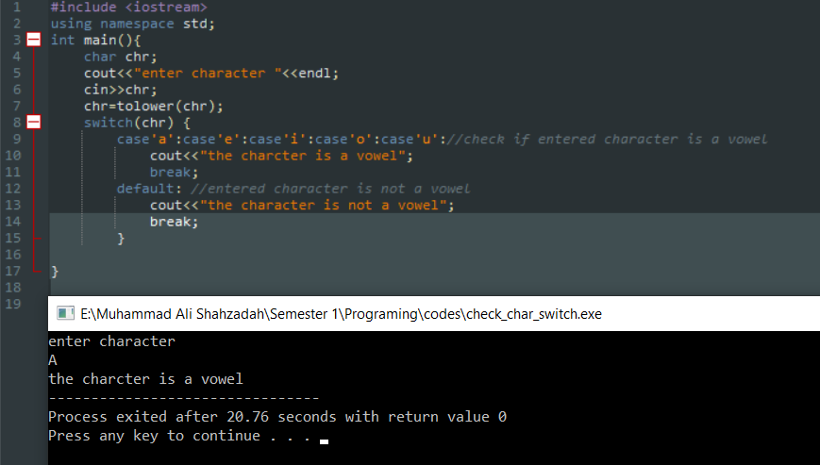

Task 3:

Write a C++ program to check whether a number is positive, negative, or zero using a switch case.

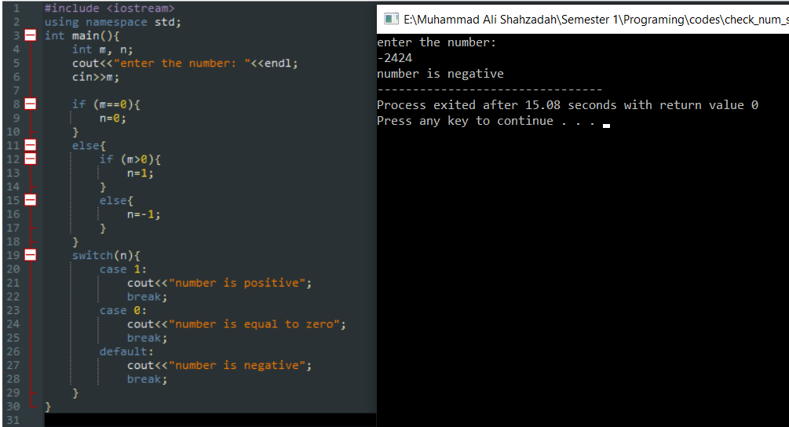

Task 4:

Write a C++ to find out whether a person is an adult, teenager, or child using nested if-else.

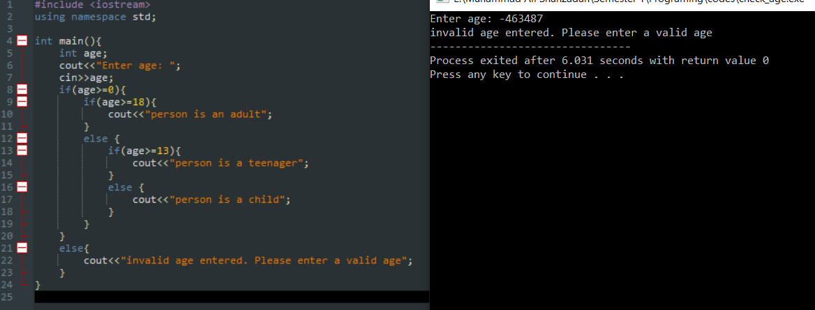

Task 5:

Write a C++ program that takes three number from the user and find the greatest number out of the three numbers using nested if-else statements.

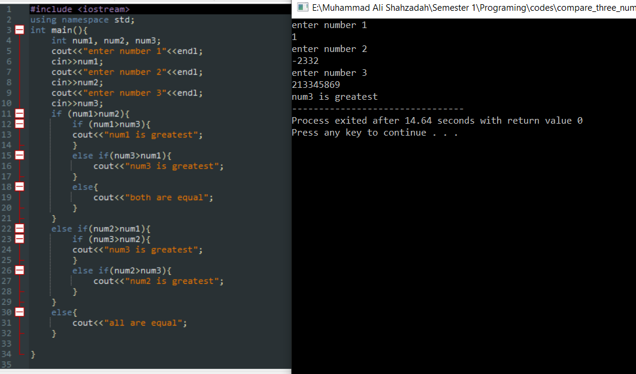

Task 6:

Write a C++ program to check whether the alphabet entered by the user is Vowel or Consonant using nested if-else.

